Extreme persistence of cratonic lithosphere in the Southwest Pacific: Paleoproterozoic Os isotopic signatures in Zealandia
Alex J. McCoy-West¹, Igor S. Puchtel², Vickie C. Bennett¹, and Richard J. Walker²
¹Research School of Earth Sciences, Australian National University, Canberra, 0200, Australia
²Isotope Geochemistry Laboratory, Department of Geology, University of Maryland, College Park, Maryland 20742, USA

ABSTRACT
Zealandia is a largely submerged, continental fragment in the Southwest Pacific, whose origins, age structure and relationships with other continental masses are poorly known. To explore the development of this key tectonic region, a suite of mantle xenoliths was assembled from 12 localities throughout New Zealand, an emergent part of Zealandia, including the North, South, and Chatham Islands. The ¹⁸⁷Re-¹⁸⁸Os isotopic systematics of 27 xenoliths yield model ages (T_{RD2}) between 0 and 2.3 Ga. The ages are geographically distributed with North Island samples being younger than those from South Island localities. Six samples from the newly defined Waitaha domain, South Island, have a narrow range of model ages from 1.6 to 1.9 Ga, in agreement with an alumochron melt depletion ‘age’ for this mantle domain of ca. 1.95 Ga, and a 3-point Re-Os isochron age of 2.26 ± 0.10 Ga. These ages are >500 Myr older than model ages preserved in other regions of mantle lithosphere from the eastern margin of Gondwana, e.g., southeastern Australia and Marie Byrd Land, Antarctica, and >1 Gyr older than the oldest crustal rocks exposed in New Zealand. Thus, the lithospheric mantle of Zealandia has a complex age structure, including a region of Paleoproterozoic cratonic mantle with a minimum extent of ca. 45,000 km². This ancient mantle resided at the margins of several supercontinents during the past ~2 Gyr, attesting to the durability of sub-continental lithospheric mantle, even when decoupled from its overlying contemporaneous crust and in an oceanic setting distanced from stable cratonic nuclei.

INTRODUCTION
The formation, preservation, and destruction of the lithospheric mantle and its role in craton growth and stabilization is a crucial, yet still poorly known component of the crust formation process. For more than 20 years, the Re-Os isotopic system has provided a useful tool for constraining the timing of lithosphere formation in continental settings. Early applications (e.g., Reisberg and Lorand, 1995; Walker et al., 1989) showed that the ages of sub-continental lithospheric mantle (SCLM) underlying ancient cratons are equal to the oldest crustal ages, first demonstrating the longevity of SCLM and implicating it in crust formation processes. Many subsequent studies have focused on determining the Re-Os characteristics of xenoliths from Precambrian continental regions. Here, we take an alternative approach to studying continental formation by examining rocks from New Zealand, an extremely young continental fragment that formed through step-wise accretion at the eastern margin of Gondwana over the last 500 Myr.
Osmium data are presented for a suite of well characterized mantle xenoliths from throughout Zealandia erupted over the last 85 Myr. Key questions focus on the comparison of the age structure of the SCLM to the oldest ages of the basement rocks. Is the underlying SCLM younger (e.g., tectonically replaced), much older (e.g., continental crust built on ancient mantle lithosphere), or the same age (e.g., felsic crust production and mantle lithosphere stabilization linked), and what are the implications for continent formation?

GEOLOGICAL SETTING
Zealandia, the broader New Zealand micro-continent, is a largely submerged (~90%) continental ribbon (>3.5 million km²) that formed on the eastern margin of Gondwana throughout the Phanerozoic. Prior to the fragmentation of Gondwana, proto-New Zealand was adjacent to Australia and Antarctica. Zealandia began to separate from Marie Byrd Land, West Antarctica, at the tip of the Chatham Rise at ca. 84 Ma (Eagles et al., 2004), and subsequently drifted ~6000 km northwest to its present location. New Zealand comprises a complex collage of geological terranes of which the Cambrian to Early Cretaceous basement is divided into two major provinces (Fig. 1), the older early Paleozoic Western Province, and the younger (late Paleozoic to mid-Cretaceous) Eastern Province, which are separated by the Median Batholith, a long-lived arc-root plutonic complex (Mortimer, 2004; Mortimer et al., 1999). The Dun Mountain-Matai terrane (Fig. 1) forms an important lineament in New Zealand geology, constraining an oceanic arc ophiolite accretion event in the mid-Permian (ca. 280 Ma) at the eastern margin of Gondwana (Kimbrough et al., 1992).
The oldest U-Pb zircon age obtained from crustal rocks in New Zealand is 515 ± 7 Ma (Münker, Ireland and Weaver, unpublished data) from the Cobb-Tunnel fault slice, Takaka terrane, Western Province (Münker and Cooper, 1999). Despite intensive geochronological investigations, no Precambrian cratonic core or evidence for Precambrian ages from crustal xenoliths have been identified. Continental intraplate volcanism, unrelated to any plume-like feature, has occurred sporadically throughout Zealandia since the mid-Cretaceous (McCoy-West et al., 2010; and references therein), and has sampled the SCLM providing, entrained mantle xenoliths.

SAMPLES AND METHODS
Peridotite xenoliths are rare within the Cenozoic volcanic sequences of New Zealand. Here, through new fieldwork and using existing collections, a comprehensive suite of mantle xenoliths has been assembled from 12 localities, including the North Island, South Island, and Chatham Islands (Fig. 1). These xenoliths are exclusively from the spinel-facies, range in size from 3 to 40 cm across, and exhibit predominantly protogranular textures with common kink-banding of olivine and minor domains of fine-grained olivine recrystallization. Of 41 mantle xenoliths examined, lherzolites (n = 23) and harzburgites (n = 14) dominate, with rare dunites (n = 2) and wehrlites (n = 2); seven crustal xenoliths were also examined. All xenoliths are from monogenetic vents, dykes or small periphery flows of larger volcanoes that have been erupted over the past 85 Myr.
Rhenium and Os concentrations and Os isotopic compositions were determined for ~1.5 g aliquots of sample powders at the University of Maryland, using Carius tube digestion and standard UMd protocols for Re-Os chemical separation and isotopic analysis (e.g., Connolly et al., 2011; Puchtel et al., 2009). Detailed descriptions of the samples, methods, and complete data sets including whole rock major element and mineral compositions are presented in the GSA Data Repository (Tables DR1–9).

RESULTS
Xenoliths have olivine forsterite contents (Fo = (100*Mg/(Mg + Fe²⁺)) ranging from 88.9 to 92.2 (Table DR1) and spinel Cr-numbers (Cr# = (100*Cr/(Al + Cr)) generally between 10 and 50, plotting on the forsterite-rich side of the olivine-spinel mantle array (Arai, 1994; Fig. DR1; Tables DR8–9). Whole rock Al₂O₃ contents are generally lower than primitive upper mantle estimates (Al₂O₃ = 4.2 wt %; Becker et al., 2006) and vary between 0.06 and 3.43 wt%, with the majority of samples having <2 wt % Al₂O₃ (Fig. 2; Tables DR6–7). Measured ¹⁸⁷Os/¹⁸⁸Os for 27 xenoliths are from 0.115 to 0.133 (Table DR1), and Os concentrations range from ~1–7 ppb, with the exception of two samples with low Os contents of only ~0.020 ppb (e.g., P43153b, P80291). Rhenium contents are generally low (<0.05 ppb), although some samples have up to ~0.3 ppb Re (e.g., MSI79C).

Re-Os Melt Extraction Ages
Model ages (Table DR1) for each sample were calculated using three approaches: T_{MA} ages, T_{RD} ages (Walker et al., 1989) and a modification of the standard Re depletion ages based on a two-stage model (T_{RD2} ages). T_{MA} and T_{RD2} represent maximum and minimum ages, respectively. For (T_{RD2}) age calculations, the initial ¹⁸⁷Os/¹⁸⁸Os isotopic composition is first calculated for the time of the host magma eruption, using the measured ¹⁸⁷Re/¹⁸⁸Os and then projected to intersection with the mantle evolution curve assuming a Re/Os = 0. T_{RD2} ages thus take into account any Re addition that may have occurred during the entrainment and eruptive process. In almost all cases here, there is no significant difference between T_{RD2} and T_{RD} ages, but for samples with high Re/Os (e.g., P43153b), or with old (>0.5 Ga) emplacement ages, this correction can have a large effect (e.g., Shirey and Walker, 1998). Calculated T_{RD2} ages for all xenoliths vary between 0 and 2.3 Ga (Table DR1; Figure 3A-B).
Eleven of the 27 samples have T_{RD2} ages from 0.83 to 0.36 Ga, comparable to the oldest U-Pb zircon ages from overlying crustal rocks; ten samples have T_{RD2} ages from 1.32 Ga-2.32 Ga. On the basis of geographic proximity and Proterozoic Re-Os model ages, we group together 5 localities to define the Waitaha (named for an ancient southern Maori iwi) domain (Table DR1; Fig. 2B). Four samples from the adjacent Fortification Peak locality are excluded from the grouping based on irregular Re-Os systematics making model age calculations less reliable (Fig. DR2). The samples with the oldest model ages from the Waitaha domain yield a narrow range of ages from 1.6 to 1.9 Ga.
As Re may be susceptible to late mobilization, elements of similar compatibility (e.g., Al₂O₃) can be used as an index of melt depletion and combined with Os isotopic compositions to estimate melt depletion ages (the so-called “alumochron”) for suites of related rocks, permitting the placement of constraints on the formation age of the SCLM (e.g., Reisberg and Lorand, 1995). An alumochron for the Waitaha domain gives a melt depletion ‘age’ of 1.94 ± 0.31 Ga (Fig. 2B). The ¹⁸⁷Re-¹⁸⁷Os data for three xenoliths from the Trig L locality yield an isochron age of 2.26 ± 0.10 Ga. As would be expected for a true isochron, rather than a fortuitous array, the ¹⁸⁷Os/¹⁸⁸Os isotopic composition determined by the intercept also yields a Paleoproterozoic T_{RD} model age (1.95 Ga). An alumochron for Trig L samples defines an age of ca. 2.10 Ga, consistent with the age defined by the Re-Os data, although with a large error due to the scatter of the major element data.
The ages of the domain, as determined by the “isochron” and the alumochron, are indistinguishable. Considered together, with the minimum 1.6–1.9 Ga model ages from xenoliths from other localities, these ages indicate a widespread mantle melting event ca. 2 Gyr ago. The Waitaha domain underlies ~30% of the South Island, extending from Banks Peninsula to Otago Peninsula, with a conservative estimate of its size being ca. 45,000 km². Additionally, two low-Re/Os xenoliths from the Chatham Islands give a formation ‘age’ of ca. 1.0 Ga. This suggests that ancient SCLM could extend under a considerable portion of Zealandia (>200,000 km²).Relative probability plots indicate a model age peak at ca. 0.5 Ga for the entire New Zealand xenolith population (Fig. 3A), which is comparable to the oldest exposed crustal rocks of New Zealand; i.e., the Middle Cambrian, Takaka Terrane, Western Province (Münker and Cooper, 1999). However, within the Waitaha domain, a much older age peak of ca. 1.7 Ga is dominant, requiring a decoupling between the age of the overlying crustal rocks and the timing of mantle lithosphere stabilization.

DISCUSSION

Distribution of Ancient Lithospheric Ages
A fundamental observation from earliest applications of the Re-Os isotopic system is that model ages of lithospheric mantle underlying cratons are typically of similar age to the oldest overlying continental basement (e.g., southern Africa, Siberia, Wyoming; Carlson and Irving, 1994; Pearson et al., 2002; Pearson et al., 1995; Walker et al., 1989). Subsequently, Os model ages for peridotite xenoliths that are much older than overlying crust have been reported in some off-cratonic regions (e.g., in southeastern Australia, Proterozoic mantle underlies Phanerozoic continental crust; Handler et al., 1997). The results presented here differ substantially from other reported occurrences of older lithospheric mantle in both the relative uniformity of ages from a single region, and in that this ancient lithospheric mantle is overlain by some of the youngest parts of New Zealand’s crustal basement comprising a Permian to Late Triassic metagreywacke sequence (e.g., Rakaia terrane; Figure 1; Wandres et al., 2004). With an age disparity of >1.5 Gyr between the crust and the underlying mantle, this is the largest age decoupling yet observed.
Furthermore, in other localities with large age differences between the SCLM and crust, there is crust of similar age in nearby cratonic regions (e.g., southeastern Australia, Canadian cordillera; Handler et al., 1997; Peslier et al., 2000). Thus, the occurrence of older lithospheric mantle has been attributed to processes like lithospheric thinning and displacement during rifting, with more ductile mantle pulled from beneath the crust, causing displacement of crust and mantle by 10–100’s of km (Handler et al., 1997). The occurrence of Paleoproterozoic mantle underlying eastern New Zealand is unique in that the closest occurrences of Paleoproterozoic crust are presently >3000 km away in cratonic Australia (e.g., Gawler Craton, South Australia).

Raft History of New Zealand’s Lithospheric Mantle
Plate reconstructions of Gondwana (Münker and Crawford, 2000) place proto-New Zealand at the eastern margin of Gondwana throughout the Phanerozoic. The presence of the Waitaha domain to the east of the Dun Mountain-Matai terrane indicates that it was a late addition to the Gondwana margin (ca. 280 Ma), and sourced from somewhere to the east of Gondwana. Looking back further in time is more speculative, but before Gondwana, the Waitaha domain may have represented a small continental ribbon that is likely to have been involved in the amalgamation of the supercontinent Rodinia, and ultimately originated as juvenile crust on the margins of the Paleoprotozoic supercontinent Nuna (Evans and Mitchell, 2011; Zhao et al., 2004). We further speculate that the Waitaha domain may have originated in western North America or East Antarctica, and formed as part of a global episode of crust production from 1.8 to 2.0 Ga, as recorded by detrital zircons and granitoid ages (Condie, 1998; Condie et al., 2009). The partial or total decoupling of this SCLM from its overlying continental crust could have occurred during the break-up of a supercontinent (either Nuna or Rodinia) through exhumation and unroofing of the mantle during extension-related lithospheric thinning, analogous to that seen at the Galicia Margin on the Iberian Peninsula (Boillot et al., 1989; Brun and Beslier, 1996).
The ages of Waitaha domain xenoliths are in distinct contrast with those from other regions of comparable upper crustal age from the eastern margin of Gondwana (Fig. 3). For example, xenoliths from the SCLM underlying Marie Byrd Land, West Antarctica and southeastern Australia have T_{RD2} age peaks at 1.1 and 1.0 Ga, respectively, and are therefore related to crustal formation associated with Rodinia rather than the older supercontinent Nuna. Melt depletion ages of the oldest Chatham Islands xenoliths are coincident with this ca. 1 Ga age, suggesting that lithospheric mantle related to Rodinia may underlie the Chatham Rise.
Our new data extend the continental life raft concept of Carlson (1995) to an extreme case, providing the clearest example of a substantially older (ca. 2.0 Ga) SCLM domain, that is likely to have been repeatedly amalgamated to the margin of at least two supercontinents (i.e., Rodinia and Gondwana), and in the process, has been decoupled from its overlying Paleoproterozoic crust. The long-lived persistence of the Waitaha domain provides further credence to the idea that ancient micro-continental blocks are required for new continental crust to stabilize (e.g., Griffin et al., 2011; Hoffman, 1988). Furthermore, this rigid mantle block may have controlled the tectonic development of New Zealand and the propagation of the Australian-Pacific plate boundary through southern Zealandia, with for example, the Alpine Fault appearing to dogleg around the western border of the Waitaha mantle block (Fig. 1)

CONCLUSIONS
Low ¹⁸⁷Os/¹⁸⁸Os measured in peridotite xenoliths sampling a large region of southern Zealandia are consistent with an ancient melt depletion event at ca. 2 Ga. The terrane of old lithospheric ages, here named the Waitaha domain, underlies a significant portion (~45000 km²) of the youngest region of New Zealand’s crustal basement and exhibits the largest age decoupling (>1.5 Gyr) yet observed between the crust and the underlying mantle lithosphere. This SCLM likely originated in a near-cratonic setting, most probably at the margin of the Paleoproterozoic supercontinent Nuna, and has subsequently been decoupled from its overlying crust for the last 1 Gyr while surviving through at least two supercontinent events. This finding extends our knowledge of the persistence of lithospheric mantle, providing an extreme example of a continental “life raft” as a long-lived, major tectonic feature and a mechanism through which new continental crust can become stabilized.

ACKNOWLEDGMENTS
AMW’s visit to UMd was supported by an ANU Vice Chancellors Travel Grant and a Jaeger Fellowship at the ANU. The analytical work at UMd was supported by grant NSF EAR-0946629 to ISP. T. Ireland, J. Hermann, H. Campbell, C. Timm, I. Smith and A. Raey are thanked for providing samples and/or discussions. B. Rapp, C. Allen and F. Brink provided analytical assistance.

REFERENCES CITED
Arai, S., 1994, Characterization of spinel peridotites by olivine-spinel compositional relationships: Review and interpretation: Chemical Geology, v. 113, p. 191–204.
Becker, H., Horan, M.F., Walker, R.J., Gao, S., Lorand, J.P., and Rudnick, R.L., 2006, Highly siderophile element composition of the Earth’s primitive upper mantle: Constraints from new data on peridotite massifs and xenoliths: Geochimica et Cosmochimica Acta, v. 70, p. 4528–4550.
Boillot, G., Feraud, G., Recq, M., and Girardeau, J., 1989, Undercrusting by serpentinite beneath rifted margins: Nature, v. 341, p. 523–525.
Brun, J.P., and Beslier, M.O., 1996, Mantle exhumation at passive margins: Earth and Planetary Science Letters, v. 142, p. 161–173.
Carlson, R.W., 1995, A continental life preserver: News and Views: Nature, v. 376, p. 116–117.
Carlson, R.W., and Irving, A.J., 1994, Depletion and enrichment history of subcontinental lithospheric mantle: An Os, Sr, Nd and Pb isotopic study of ultramafic xenoliths from the northwestern Wyoming Craton: Earth and Planetary Science Letters, v. 126, p. 457–472.
Condie, K.C., 1998, Episodic continental growth and supercontinents: A mantle avalanche connection?: Earth and Planetary Science Letters, v. 163, p. 97–108.
Condie, K.C., Belousova, E., Griffin, W.L., and Sircombe, K.N., 2009, Granitoid events in space and time: Constraints from igneous and detrital zircon age spectra: Gondwana Research, v. 15, p. 228–242.
Connolly, B.D., Puchtel, I.S., Walker, R.J., Arevalo, R., Jr., Piccoli, P.M., Byerly, G., Robin-Popieul, C., and Arndt, N., 2011, Highly siderophile element systematics of the 3.3 Ga Weltevreden komatiites, South Africa: Implications for early Earth history: Earth and Planetary Science Letters, v. 311, p. 253–263.
Eagles, G., Gohl, K., and Larter, R.D., 2004, High-resolution animated tectonic reconstruction of the South Pacific and West Antarctic margin: Geochemistry Geophysics Geosystems, v. 5, Q07002, doi:10.1029/2003GC000657.
Evans, D.A.D., and Mitchell, R.N., 2011, Assembly and breakup of the core of Paleoproterozoic-Mesoproterozoic supercontinent Nuna: Geology, v. 39, p. 443–446.
Griffin, W.L., Begg, G.C., Dunn, D., O’Reilly, S.Y., Natapov, L.M., and Karlstrom, K., 2011, Archean lithospheric mantle beneath Arkansas: Continental growth by microcontinent accretion: Geological Society of America Bulletin, v. 123, p. 1763–1775.
Handler, M.R., Bennett, V.C., and Esat, T.M., 1997, The persistence of off-cratonic lithospheric mantle: Os isotopic systematics of variably metasomatised southeast Australian xenoliths: Earth and Planetary Science Letters, v. 151, p. 61–75.
Handler, M.R., Wysoczanski, R.J., and Gamble, J.A., 2003, Proterozoic lithosphere in Marie Byrd Land, West Antarctica: Re-Os systematics of spinel peridotite xenoliths: Chemical Geology, v. 196, p. 131–145.
Hoffman, P.F., 1988, United plates of America, the birth of a craton: Early Proterozoic assembly and growth of Laurentia: Annual Review of Earth and Planetary Sciences, v. 16, p. 543–603.
Kimbrough, D.L., Mattinson, J.M., Coombs, D.S., Landis, C.A., and Johnston, M.R., 1992, Uranium-lead ages from the Dun Mountain ophiolite belt and Brook Street terrane, South Island, New Zealand: Geological Society of America Bulletin, v. 104, p. 429–443.
Ludwig, K.R., 2008, Isoplot 3.71, Berkeley Geochronology Centre.
McCoy-West, A.J., Baker, J.A., Faure, K., and Wysoczanski, R., 2010, Petrogenesis and origins of mid-Cretaceous continental intraplate volcanism in Marlborough, New Zealand: Implications for the long-lived HIMU magmatic mega-province of the SW Pacific: Journal of Petrology, v. 51, p. 2003–2045.
Meisel, T., Walker, R.J., Irving, A.J., and Lorand, J.-P., 2001, Osmium isotopic compositions of mantle xenoliths: A global perspective: Geochimica et Cosmochimica Acta, v. 65, p. 1311–1323.
Mortimer, N., 2004, New Zealand’s geological foundations: Gondwana Research, v. 7, p. 261–272.
Mortimer, N., Gans, P., Calvert, A., and Walker, N., 1999, Geology and thermochronometry of the east edge of the Median Batholith (Median Tectonic Zone): A new perspective on Permian to Cretaceous crustal growth of New Zealand: The Island Arc, v. 8, p. 404–425.
Münker, C., and Cooper, R., 1999, The Cambrian arc complex of the Takaka Terrane, New Zealand: An integrated stratigraphical, paleontological and geochemical approach: New Zealand Journal of Geology and Geophysics, v. 42, p. 415–445.
Münker, C., and Crawford, A.J., 2000, Cambrian arc evolution along the SE Gondwana active margin: A synthesis from Tasmania-New Zealand-Australia-Antarctica correlations: Tectonics, v. 19, p. 415–432.
Pearson, D.G., Shirey, S.B., Carlson, R.W., Boyd, F.R., Pokhilenko, N.P., and Shimizu, N., 1995, Re-Os, Sm-Nd, and Rb-Sr isotope evidence for thick Archaean lithospheric mantle beneath the Siberian craton modified by multistage metasomatism: Geochimica et Cosmochimica Acta, v. 59, p. 959–977.
Pearson, D.G., Irvine, G.J., Carlson, R.W., Kopylova, M.G., and Ionov, D.A., 2002, The development of lithospheric keels beneath the earliest continents: time constraints using PGE and Re-Os isotope systematics: Geological Society of London Special Publication 199, p. 65–90.
Peslier, A.H., Reisberg, L., Ludden, J., and Francis, D., 2000, Os isotopic systematics in mantle xenoliths: Age constraints on the Canadian Cordillera lithosphere: Chemical Geology, v. 166, p. 85–101.
Puchtel, I.S., Walker, R.J., Anhaeusser, C.R., and Gruau, G., 2009, Re-Os isotope systematics and HSE abundances of the 3.5 Ga Schapenburg komatiites, South Africa: Hydrous melting or prolonged survival of primordial heterogeneities in the mantle?: Chemical Geology, v. 262, p. 355–369.
Reisberg, L., and Lorand, J.P., 1995, Longevity of sub-continental mantle lithosphere from osmium isotope systematics in orogenic peridotite massifs: Nature, v. 376, p. 159–162.
Shirey, S.B., and Walker, R.J., 1998, The Re-Os isotope system in cosmochemistry and high-temperature geochemistry: Annual Review of Earth and Planetary Sciences, v. 26, p. 423–500.
Walker, R.J., Carlson, R.W., Shirey, S.B., and Boyd, F.R., 1989, Os, Sr, Nd, and Pb isotope systematics of southern African peridotite xenoliths: Implications for the chemical evolution of subcontinental mantle: Geochimica et Cosmochimica Acta, v. 53, p. 1583–1595.
Wandres, A.M., Bradshaw, J.D., Weaver, S., Maas, R., Ireland, T., and Eby, N., 2004, Provenance of the sedimentary Rakaia sub-terrane, Torlesse Terrane, South Island, New Zealand: The use of igneous clast compositions to define the source: Sedimentary Geology, v. 168, p. 193–226.
Zhao, G., Sun, M., Wilde, S.A., and Li, S., 2004, A Paleo-Mesoproterozoic supercontinent: Assembly, growth and breakup: Earth-Science Reviews, v. 67, p. 91–123.

FIGURES

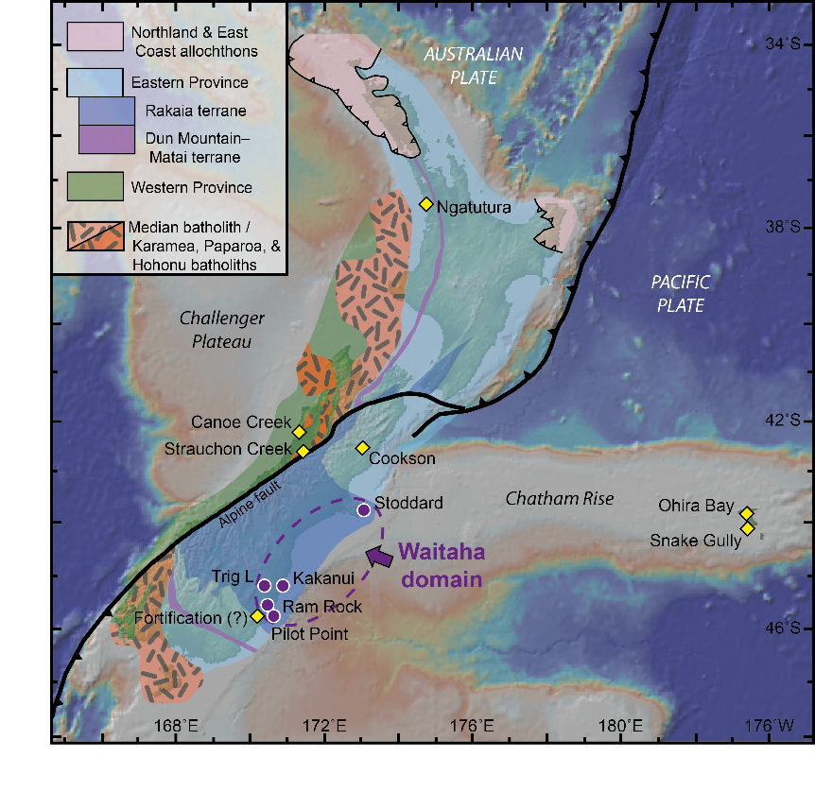
Figure 1. Simplified geological map of New Zealand’s crustal basement showing the major lithostratigraphic divisions. Mantle xenolith localities are divided into two groups: 1) the Waitaha domain (circles), 2) all other localities (diamonds). The dashed ellipse represents the minimum extent of the newly recognized Paleoproterozoic, Waitaha domain. Geology modified from Mortimer (2004).

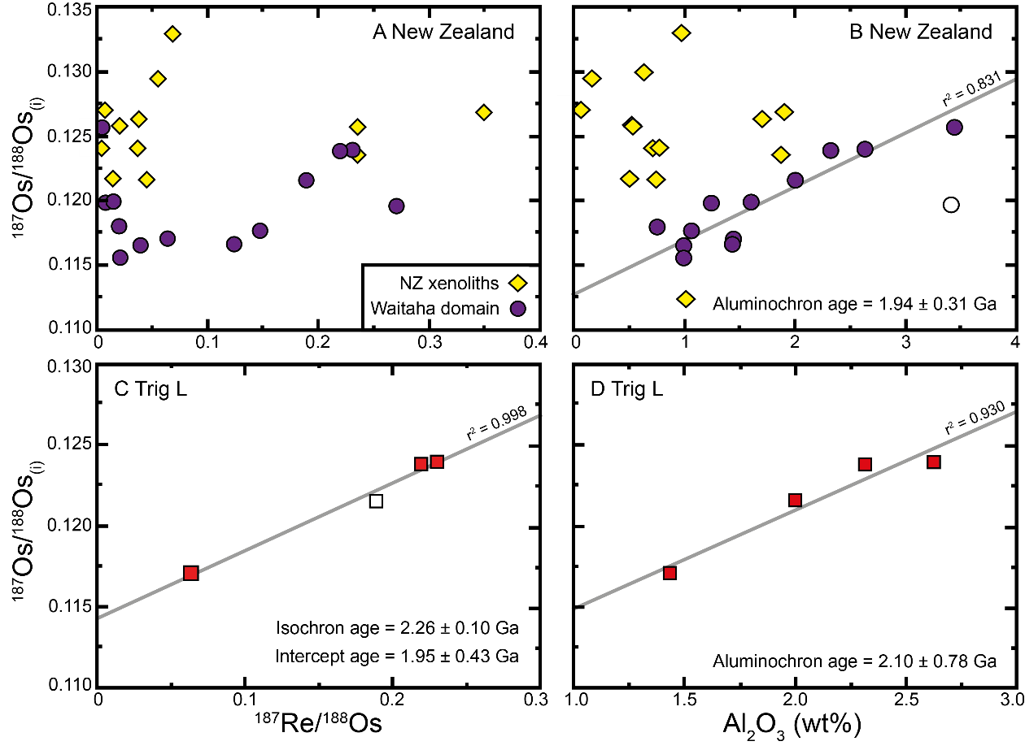
Figure 2. ¹⁸⁷Os/¹⁸⁸Os_{(i)} (calculated for the time of eruption) versus ¹⁸⁷Re/¹⁸⁸Os and Al₂O₃ wt % for Zealandian mantle xenoliths (A-B), and samples from a single locality (Trig L) within the Waitaha domain (C-D). A) There is a general correlation between ¹⁸⁷Os/¹⁸⁸Os and ¹⁸⁷Re/¹⁸⁸Os for samples within the Waitaha domain. B) A stronger correlation is observed between Al₂O₃ wt % and ¹⁸⁷Os/¹⁸⁸Os (r² = 0.831; n = 12) providing an “alumochron” Re extraction age (Al_{0.60}) of 1.94 ± 0.31 Ga; a comparable age (2.18 ± 0.56 Ga) is obtained if CaO is substituted as the melt depletion index. C) The 3-point Re-Os isochron age of 2.26 ± 0.10 Ga (MSWD = 1.4; Ludwig, 2008) is coincident with the four point age, although with larger error (2.21 ± 1.0 Ga; MSWD = 13; r² = 0.982). D). The Trig L “alumochron” age (Al_{0.92}) of 2.1 ± 1.2 Ga is within error of the ‘isochron’ age, although with a large error due to the scatter in Al contents. Model ages are calculated using the parameters presented in Table DR1.
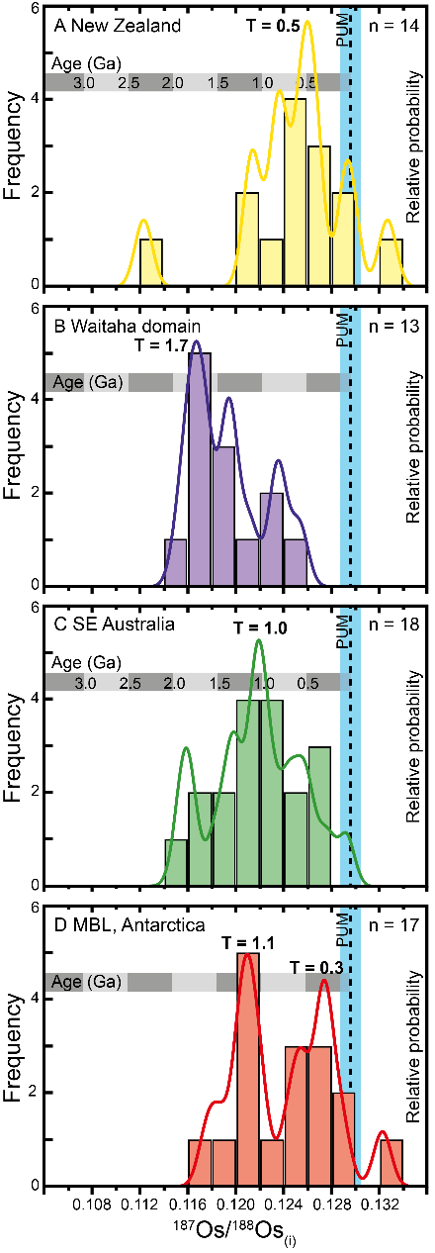
Figure 3. Histograms of initial ¹⁸⁷Os/¹⁸⁸Os comparing mantle xenoliths from A) New Zealand (this study); B) Waitaha domain (this study); C) southeastern Australia (Handler et al., 1997); and D) Marie Byrd Land, Antarctica (Handler et al., 2003). Dotted line represents the composition of the modern primitive upper mantle ¹⁸⁷Os/¹⁸⁸Os = 0.1296 ± 8 (Meisel et al., 2001). Grey bar shows Re depletion ages corresponding to the ¹⁸⁷Os/¹⁸⁸Os isotopic compositions. Lines overlying the histograms represent relative probability density plots of T_{RD2} model ages; bold numbers are major age peaks. Samples from the Waitaha domain are significantly older than any other sampled Gondwanaian mantle region.

¹GSA Data Repository item 2012xxx, Description of Samples, Methods, Figures, and Tables, is available online at www.geosociety.org/pubs/ft2012.htm, or on request from editing@geosociety.org or Documents Secretary, GSA, P.O. Box 9140, Boulder, CO 80301, USA

