**Appendix**

**Table S1.** Morphological metrics used to estimate the age of *Conomuurex luhuanus* in previous studies (after Catterall et al., 2001).

|  |  |  |
| --- | --- | --- |
| **Age Class** | **Age (years)** | **Definition** |
| Adult | > 3 | Lip thickness > 4mm |
| Adolescent | 2-3 | Lip thickness 2-3.9 mm |
| Yearling | 1-2 | Lip thickness <2 mm; shell length at least three-quarters of the location-specific mean adult length. Age of maturity is 2 yrs. |
| Recruit | 0-1 | Lip thickness <2mm; shell length less than three-quarters of the location-specific mean adult length |

**Table S2.** Shell collection information. The samples were collected during the cold season during low tide in 2019 and 2023. Y = The shells were analysed in this study. N = The specimens were not used in this study due to not having a thick enough lip.

|  |  |  |  |  |  |  |
| --- | --- | --- | --- | --- | --- | --- |
| **Sampling Date** | **Samples ID** | **Weight**  **(g)** | **Length**  **(mm)** | **Lip Thickness**  **(mm)** | **δ18O**  **Analysis** | **Shell Mineralogy** |
| 29 September 2019 | C-11 | 24.1 | 51.6 | 4.7 | Y | Y |
| C-12 | 13.1 | 51.3 | 2.1 | Y | Y |
| C-13 | 17.9 | 48.9 | 4.1 | Y | Y |
| 30 August  2023 | SI-30-C-1 | 29.3 | 50.7 | 4.5 | Y | Y |
| SI-30-C-2 | 28.2 | 50.5 | 4.0 | N | N |
| SI-30-C-3 | 19.7 | 45.7 | 3.1 | N | Y |
| SI-30-C-4 | 28.2 | 50.2 | 4.4 | Y | Y |
| SI-30-C-5 | 19.4 | 43.0 | 4 | Y | N |
| SI-30-C-6 | 23.5 | 46.6 | 4.2 | Y | N |
| SI-30-C-7 | 21.2 | 45.0 | 4.3 | Y | N |
| SI-30-C-8 | 24.7 | NA | Broken lip | N | N |
| SI-30-C-9 | 27.2 | 49.7 | 5.9 | Y | Y |
| SI-30-C-10 | 24.0 | 48.2 | 4.0 | Y | N |
| SI-30-C-11 | 22.5 | 46.7 | 3.6 | N | N |

**Table S3.** Seawater samples were collected on 28-30 August 2023 in nine different locations across Jiigurru during high and low tide. The δ18Osw values are reported in ‰VPDB. For this study, the δ18Osw from the intertidal zone near the shell collection (Water sample number 2) is used in the equation of Grossman and Ku (1986). The water sample number locations can be seen in Fig. 1.

|  |  |  |  |  |  |
| --- | --- | --- | --- | --- | --- |
| **Number of water samples** | **δ18Osw (‰ VPDB)** | **Max** | **Min** | **Range** | **Mean** |
| 12 | High tide (intertidal zone) | 0.58 | 0.44 | 0.14 | 0.51±0.01 |
| 9 | Low tide (intertidal zone) | 0.63 | 0.48 | 0.15 | 0.54±0.01 |
| 7 | Rising tide (intertidal zone) | 0.66 | 0.44 | 0.21 | 0.55±0.02 |
| 2 | Intertidal zone near shell collection site | 0.63 | 0.62 | 0.01 | 0.63±0.002 |
| 2 | Blue Lagoon | 0.52 | 0.37 | 0.15 | 0.44±0.07 |

**Table S4.** 32seawater samples were collected on 28-30 August 2023 in nine different locations across Jiigurru during high and low tide. The δ18Osw values are reported in ‰VPDB.

|  |  |  |  |  |  |  |
| --- | --- | --- | --- | --- | --- | --- |
| **Sample_ID** | **Corr d18O** | **95% uncertainty** | **Corr dD** | **95% uncertainty** | **Location** | **Tide** |
| SI-30-R1-1 | 0.44 | 0.10 | -1.44 | 1.50 | Boulder_granit | Rising tide |
| SI-30-R1-2 | 0.53 | 0.10 | 1.29 | 1.58 | Boulder_granit | Rising tide |
| SI30-R2-1 | 0.51 | 0.12 | 0.28 | 1.68 | Rdge_Reef | Rising tide |
| SI-30-R2-2 | 0.45 | 0.10 | 0.97 | 1.56 | Rdge_Reef | Rising tide |
| SI30-C-1-1 | 0.63 | 0.12 | 3.08 | 1.51 | Near *Conomurex* | Rising tide |
| SI30-C-1-2 | 0.62 | 0.10 | -0.82 | 2.05 | Near *Conomurex* | Rising tide |
| SI30-01 | 0.49 | 0.13 | 3.28 | 1.70 | South Island | High tide |
| SI30-02 | 0.47 | 0.09 | 3.52 | 1.48 | South Island | High tide |
| SI30-03 | 0.63 | 0.10 | 4.12 | 1.24 | South Island | Low tide |
| SI30-04 | 0.49 | 0.11 | 2.91 | 1.30 | South Island | Low tide |
| SI30-05 | 0.54 | 0.12 | 2.50 | 1.69 | South Island | Low tide |
| SI30-06 | 0.53 | 0.10 | 3.78 | 1.28 | South Island | Low tide |
| SI30-07 | 0.61 | 0.10 | 3.68 | 1.02 | Rocky pool | Rising tide |
| SI30-08 | 0.66 | 0.11 | 3.57 | 0.95 | Rocky pool | Rising tide |
| FB29-01 | 0.59 | 0.12 | 2.01 | 1.60 | Freshwater Bay | High tide |
| FB29-02 | 0.45 | 0.11 | 3.31 | 1.26 | Freshwater Bay | High tide |
| FB29-34 | 0.48 | 0.13 | 3.68 | 1.55 | Freshwater Bay | Low tide |
| FB29-56 | 0.51 | 0.14 | 4.06 | 1.57 | Freshwater Bay | Low tide |
| BL29-01 | 0.37 | 0.12 | 2.81 | 1.24 | Blue Lagoon | High tide |
| BL29-02 | 0.52 | 0.11 | 3.82 | 1.31 | Blue Lagoon | High tide |
| MB29-01 | 0.56 | 0.10 | 3.32 | 1.03 | Mangrove Beach | High tide |
| MB29-02 | 0.47 | 0.13 | 3.62 | 1.55 | Mangrove Beach | High tide |
| MB29-03 | 0.49 | 0.15 | 3.27 | 1.94 | Mangrove Beach | High tide |
| MB29-45 | 0.57 | 0.14 | 4.52 | 1.64 | Mangrove Beach | Low tide |
| CG01-01 | 0.49 | 0.11 | 0.59 | 1.54 | Clam Garden | Rising tide |
| CG01-02 | 0.55 | 0.11 | 1.73 | 1.57 | Clam Garden | Rising tide |
| L28-01 | 0.56 | 0.11 | 3.51 | 1.06 | Limoos Beach | High tide |
| L28-02 | 0.52 | 0.08 | 2.69 | 0.92 | Limoos Beach | High tide |
| L28-03 | 0.54 | 0.20 | 3.56 | 1.01 | Limoos Beach | Low tide |
| L28-04 | 0.60 | 0.11 | 3.55 | 0.91 | Limoos Beach | Low tide |
| L28-05 | 0.55 | 0.08 | 2.06 | 1.19 | Limoos Beach | High tide |
| L28-06 | 0.57 | 0.10 | 3.12 | 1.02 | Limoos Beach | High tide |

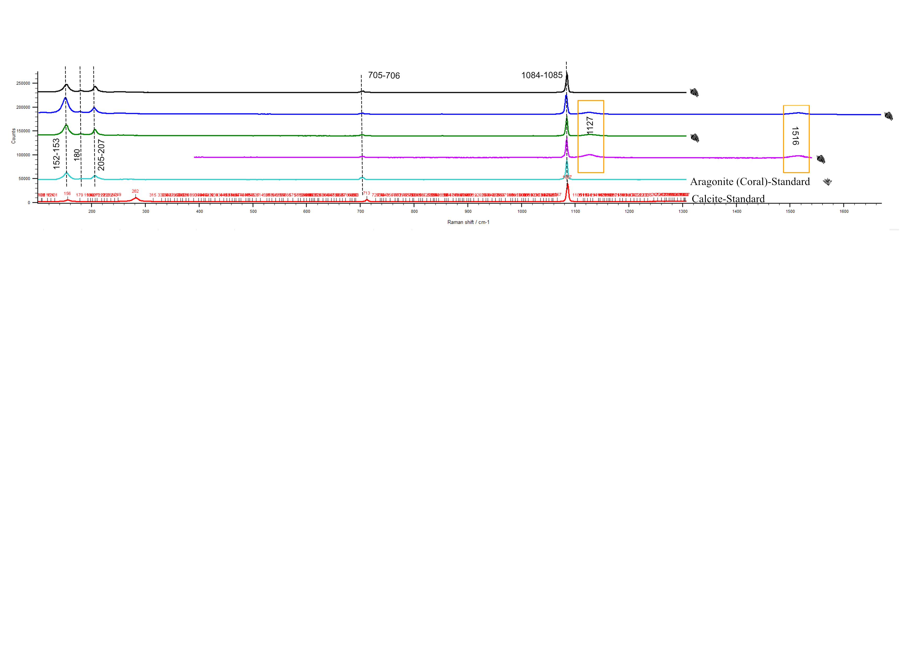

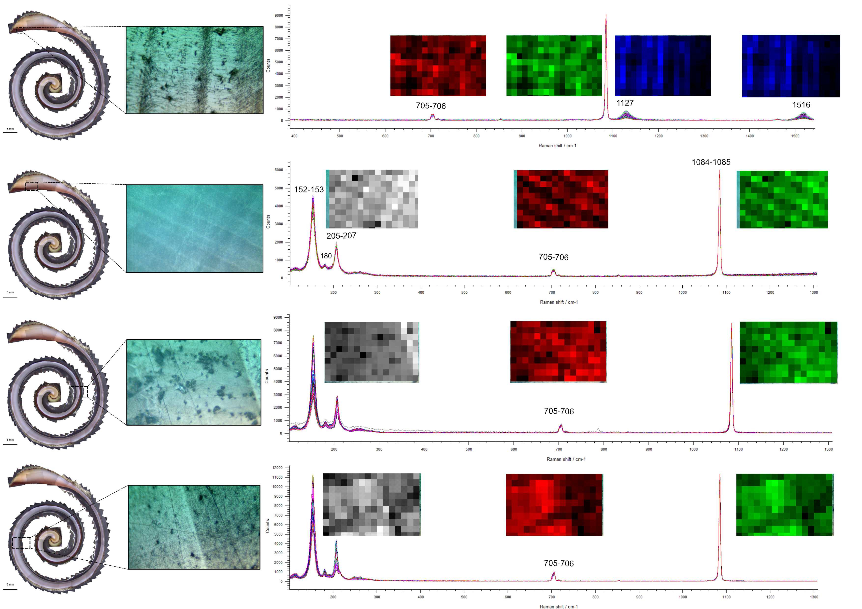

**Figure S1.** The mineralogy of *Conomurex luhuanus* shells using Raman spectroscopy. Top panel: averaged Raman spectra of *C. luhuanus* were obtained from different portions of the shell. Aragonite peaks are identified at 152-153, 180, 205-207, 705-706, and 1084-1085 cm-1. Peaks linked to 1127 and 1516 cm-1 were identified as carotenoids. The same result was reported for *C. fasciatus* (Hausmann et al., 2017). Bottom panel: the same peaks for different parts of the shell along with mosaic spectra showing that all parts of the shell are made of aragonite.

**Figure S2.** Comparing incremental growth increments with tidal cycles. Sample C-12 was the smallest shell collected on 29 September 2019 (spring tide). Growth increments matched with tidal cycles and represented exact lunar calendar dates at Jiigurru.