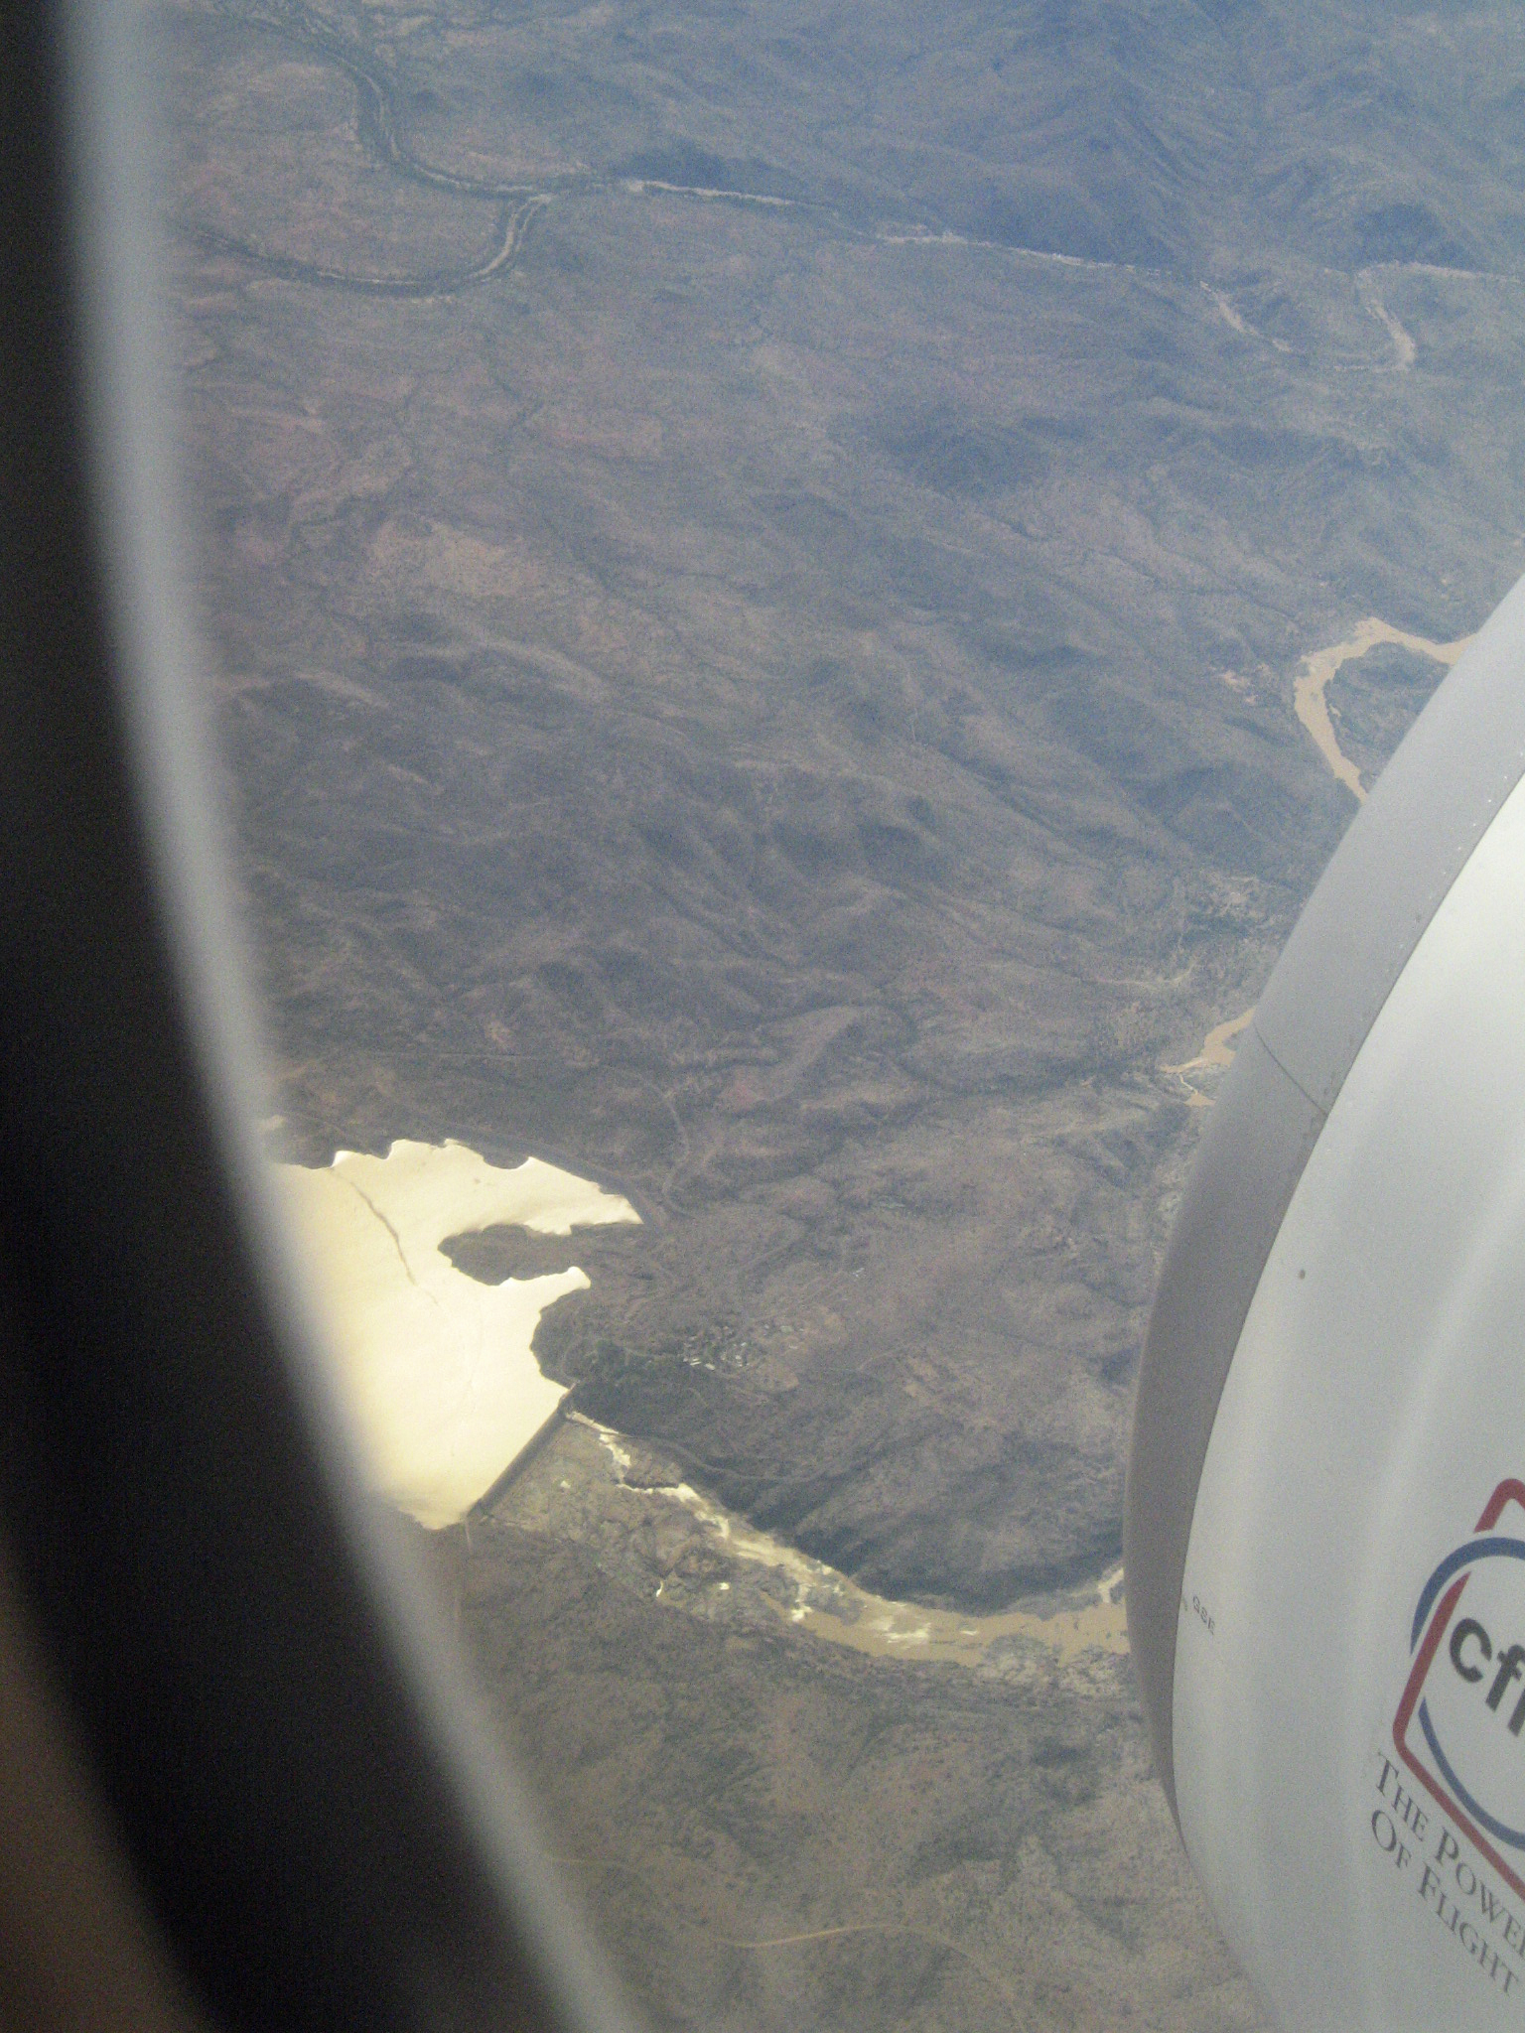
Burdekin Dam 2006

Watersheds and Basins

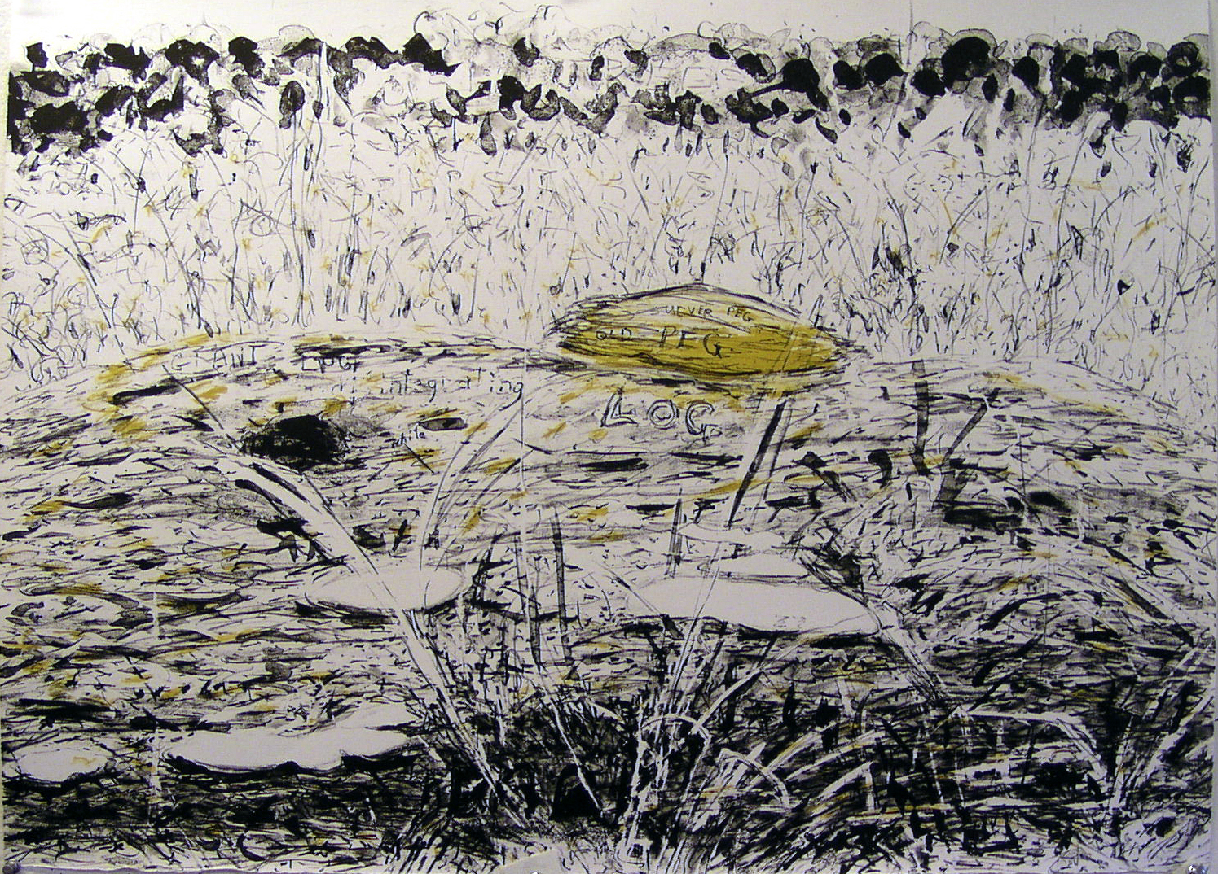

Yellow Peg Lithograph Anne Lord 2005

